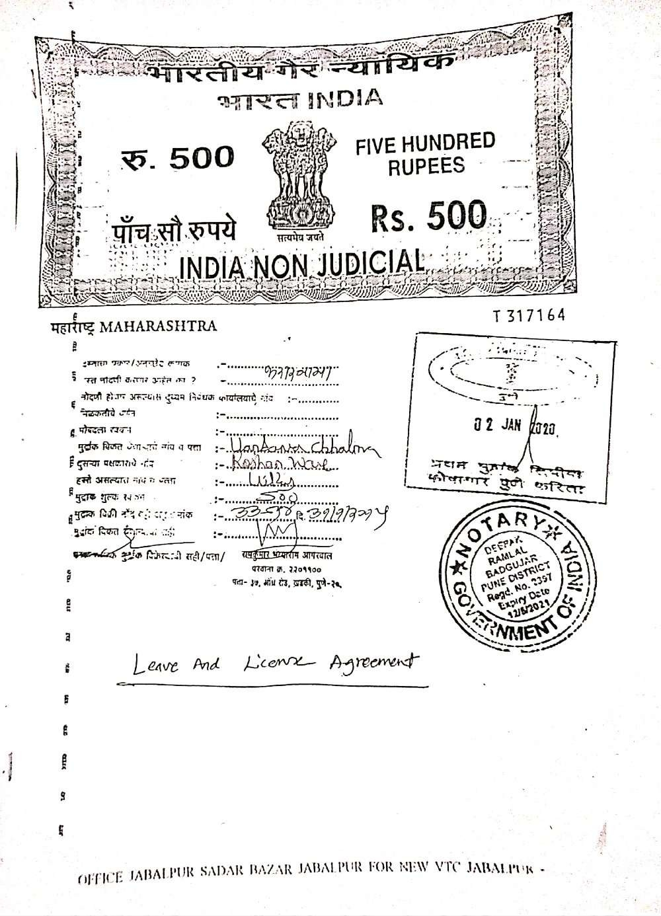

**LEAVE AND LICENCE AGREEMENT**

THIS AGREEMENT OF LEAVE AND LICENCE made at Pune on **2nd day of Jan Two thousand twenty** BETWEEN **Vandana Chhabra owner of Flat 301, F wing Crescent building The Woods- Mahindra Gesco Developers Limited Near Kalewadi chowk Aundh Annexe Wakad Pune** currently residing at Flat no. 101 Royal Resort Tower Shastri Nagar 'Lokhandwala Complex Andheri (West) Mumbai -400053 hereinafter referred to as the “Licensor”(which expression shall unless it be repugnant to the context or meaning thereof be deemed to mean and include his/her heirs, executers, administrators, representatives and assigns) of the other part ;

AND

1. **MR. ROSHAN WARE**

**Age:** 25 Yrs.

**Occupation-** Service (Bitwise Baner Pune)

**Permanent Address** -PLOT 362, KADIVALI, DAPOLI, RATNAGIRI 415712.

**Phone- 8080515474**

1. **MR. PRAKASH CHOUBEY**

**Age:** 24 Yrs.

**Occupation-** Service (Bitwise Baner Pune)

**Permanent address-** VILL+POST- SURAJPURA, BALLIA, UTTAR PRADESH 277301.

**Phone:** 7276677843

1. **MR. RISHI KANOJIA**

**Age:** 26

**Occupation:** Service (Capgemini Talwade)

**Permanent address:** 407/5, GORAKHPUR, JABALPUR, MADHYA PRADESH

**Phone:** 9168177587

1. **MR. VINIT MARU**

**Age:** 26

**Occupation:** Service (Mindtree)

**Permanent address:** MADHAV NAGAR, PLOT NO: 15, MADHURAM, JUNAGADH, GUJARAT

**Phone:** 8605191945

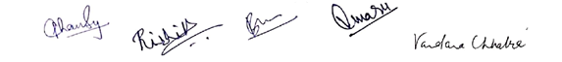

Hereinafter referred to as “The Licensee”, which expression shall, unless it be repugnant to the subject or context thereof be deemed to include its successors and assigns of the **OTHER PART.**

WHEREAS the licensors is the exclusive and lawful owner of absolutely seized and possessed of or otherwise well and sufficiently entitled to the premises more particularly described in the annexure hereto (hereinafter referred to as “The said flat”).

****AND WHEREAS the LICENSEE being in need of the residential premises has approached the LICENSOR the Licensee has agreed to take the said flat on Leave and Licence for the residential use only.

The Licensor has agreed to give the said flat on Leave and Licence for the residential use on the terms and conditions as detailed hereunder:

NOW THEREFORE THIS AGREEMENT WITNESSETH AND IS HEREBY AGREED UPON BETWEEN THE PARTIES HERETO AS FOLLOWS:

1. The Licensor hereby grants into Licensee and the Licensee hereby takes on leave and license the said flat temporarily for the residential use for a period of 11 months (Eleven Months) commencing from **Jan 02, 2020 to Dec 02, 2020.**
2. The said flat shall be used only for residence of the said employee and his/her family and no other purpose whatsoever.
3. The Licensee shall pay to the Licensor compensation of net rent of **Rs. 34000 /- (Rupees Thirty Four Thousand only)** per month of the said flat for 11 months lease commencing from Jan 02, 2020 to Dec 02,2020 and thereafter an increase/escalation of 15 % on monthly compensation,
4. The compensation so stipulated shall be paid by the Licensee to the Licensor on or before the 1st day of each month in advance.
5. In consideration of Licensor having agreed to give or given on Leave and License basis the said flat to the Licensee, the Licensee has agreed to on the account of the said employee refundable deposit with the Licensor a sum of Rs 1, 00,000 /- (Rupees One Lac only) on the day of this agreement refundable security deposit (“The security deposit”) to be held free of interest for due fulfilment of all the terms and conditions of the Leave and License Agreement. The Licensor shall be entitled to adjust any claim they may have against the LICENSEE under this agreement. The deposit or balance thereof shall be returned only at the time of LICENSEE satisfying the LICENSORS that the obligations under this license are fulfilled that is all the bills towards electricity, telephone, cable network etc. have been paid or provided

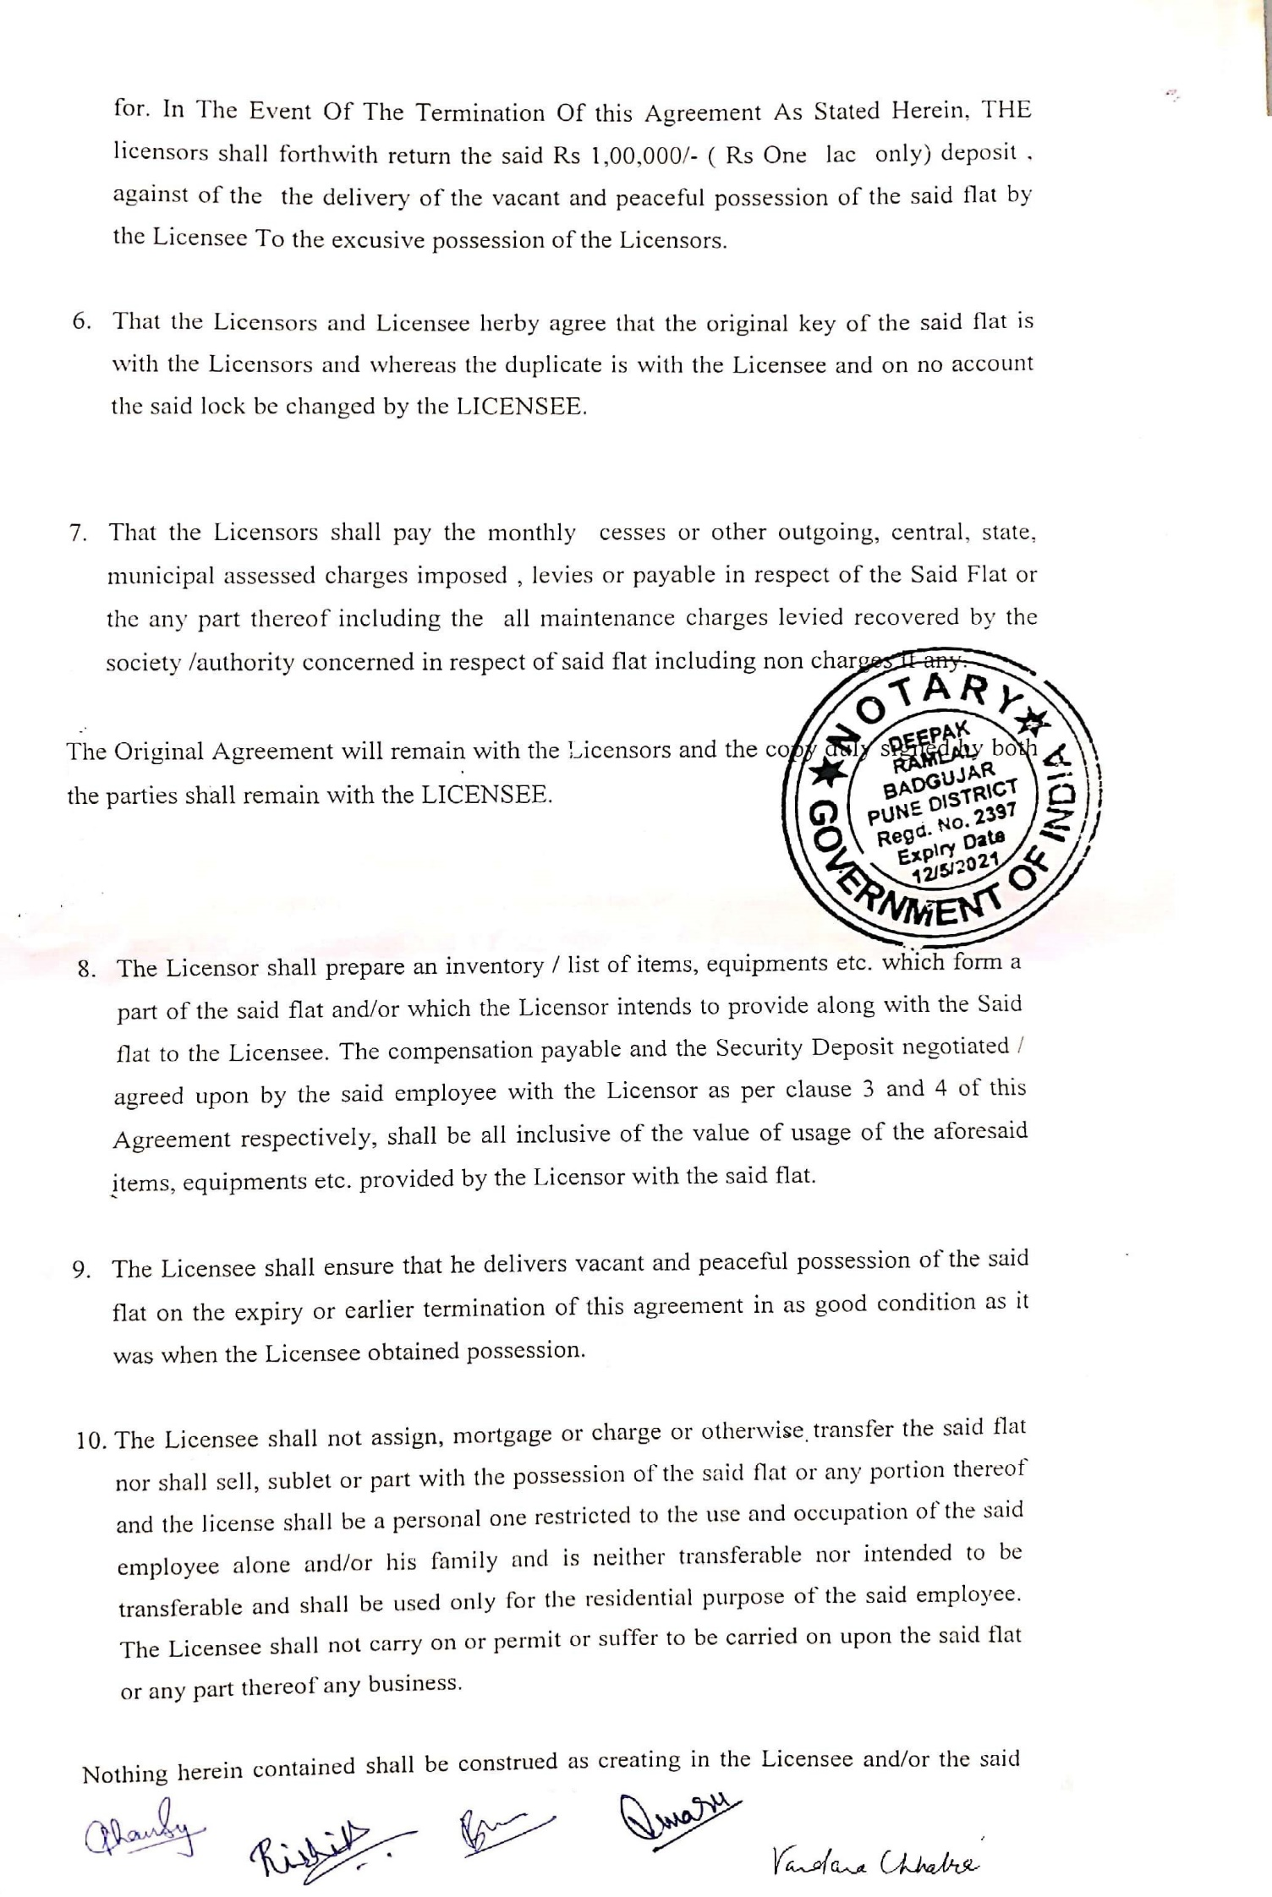

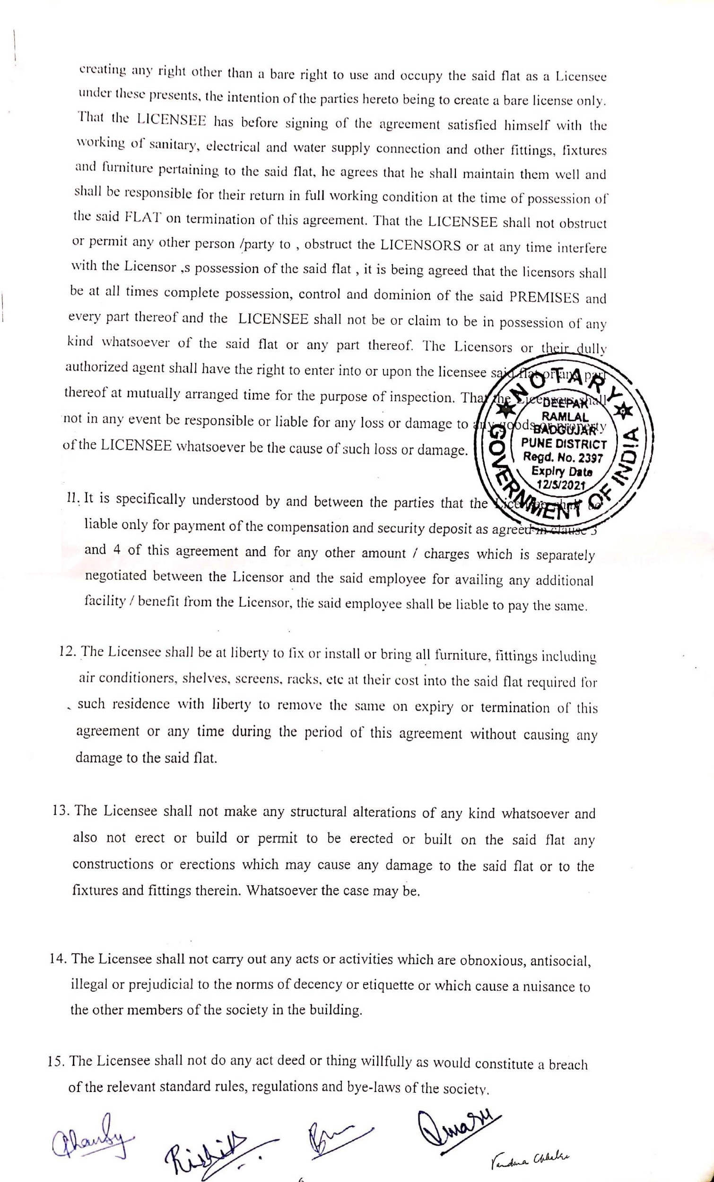

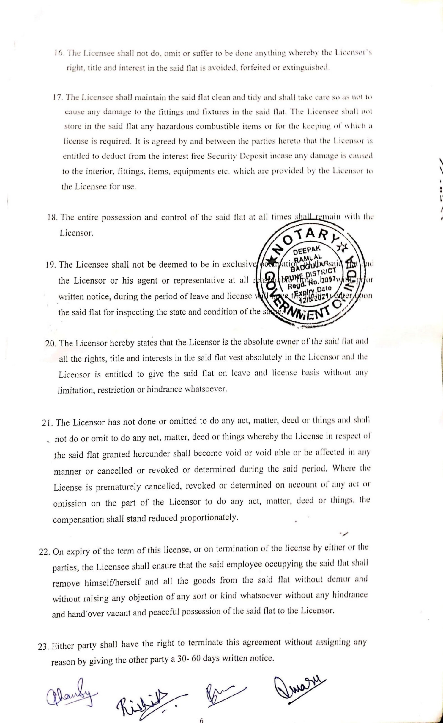

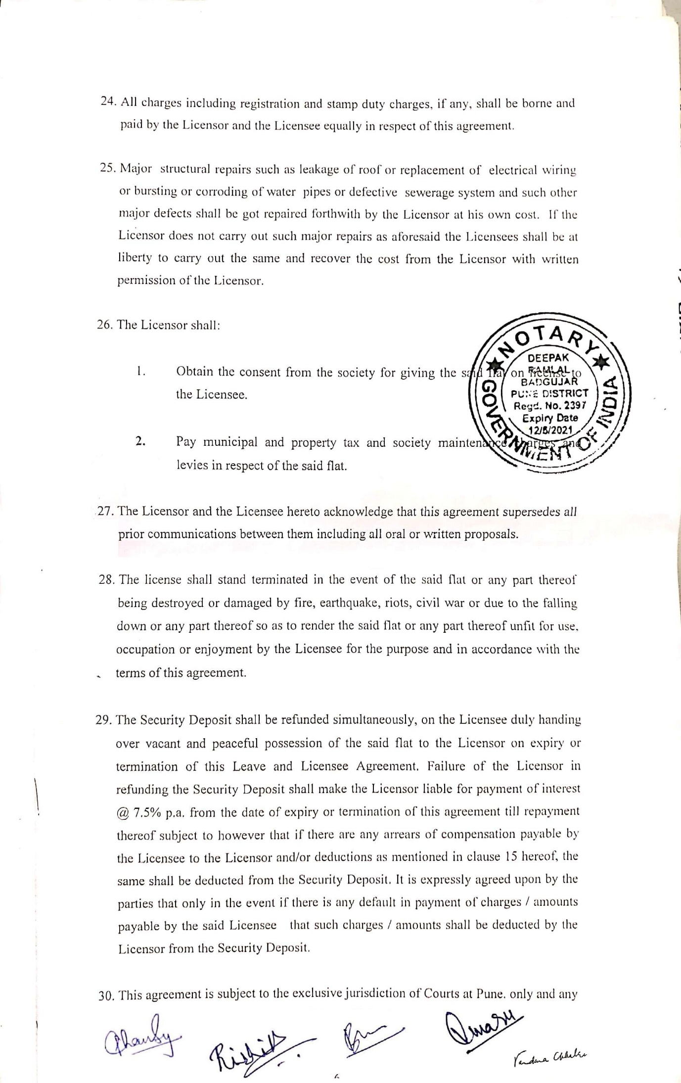

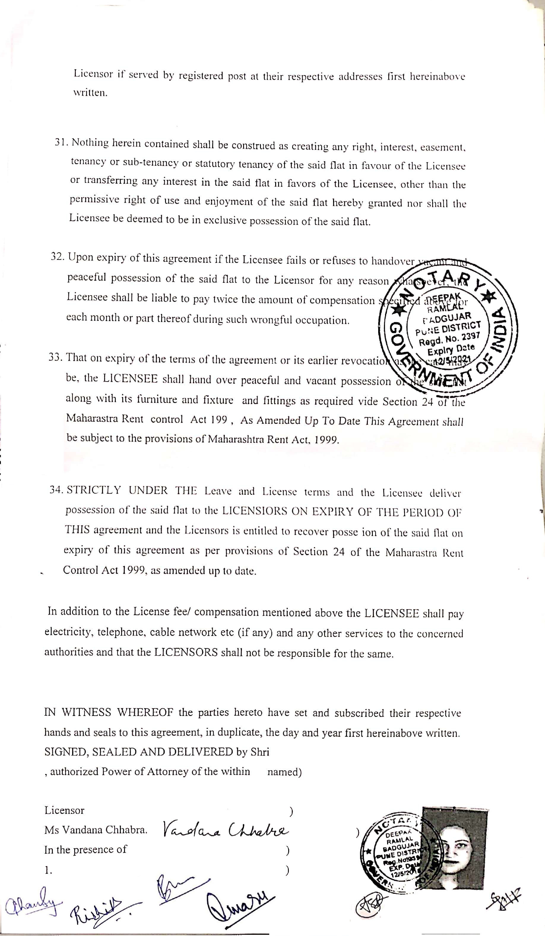

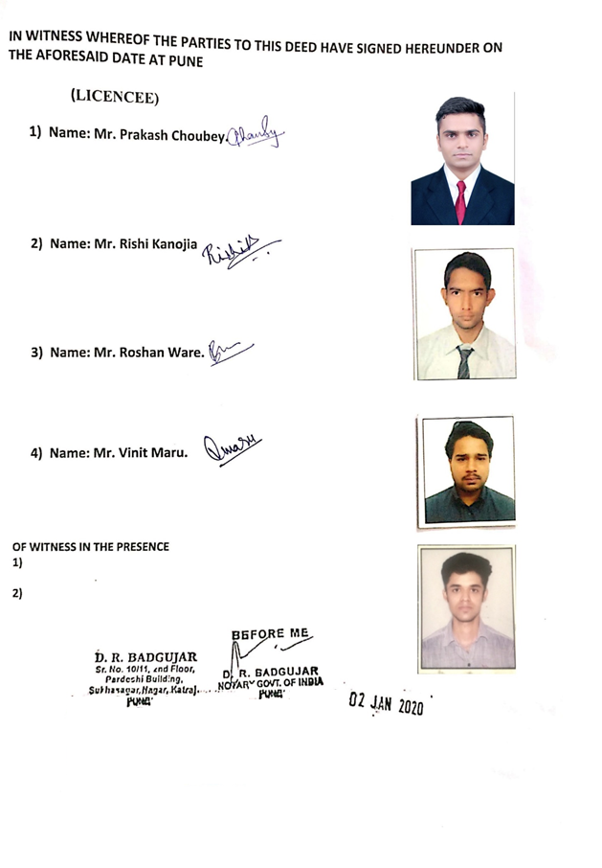

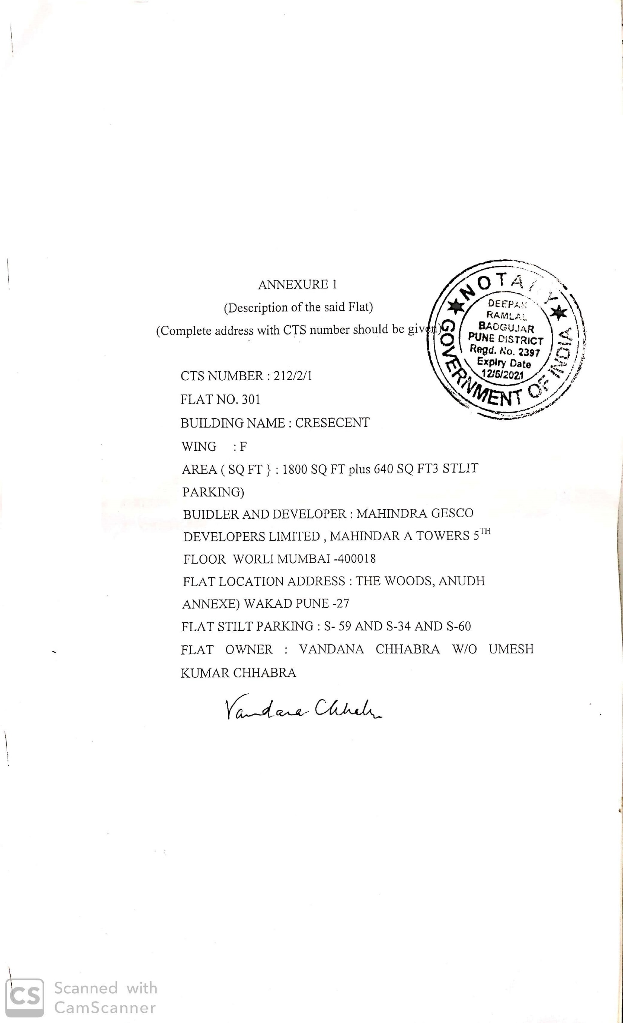

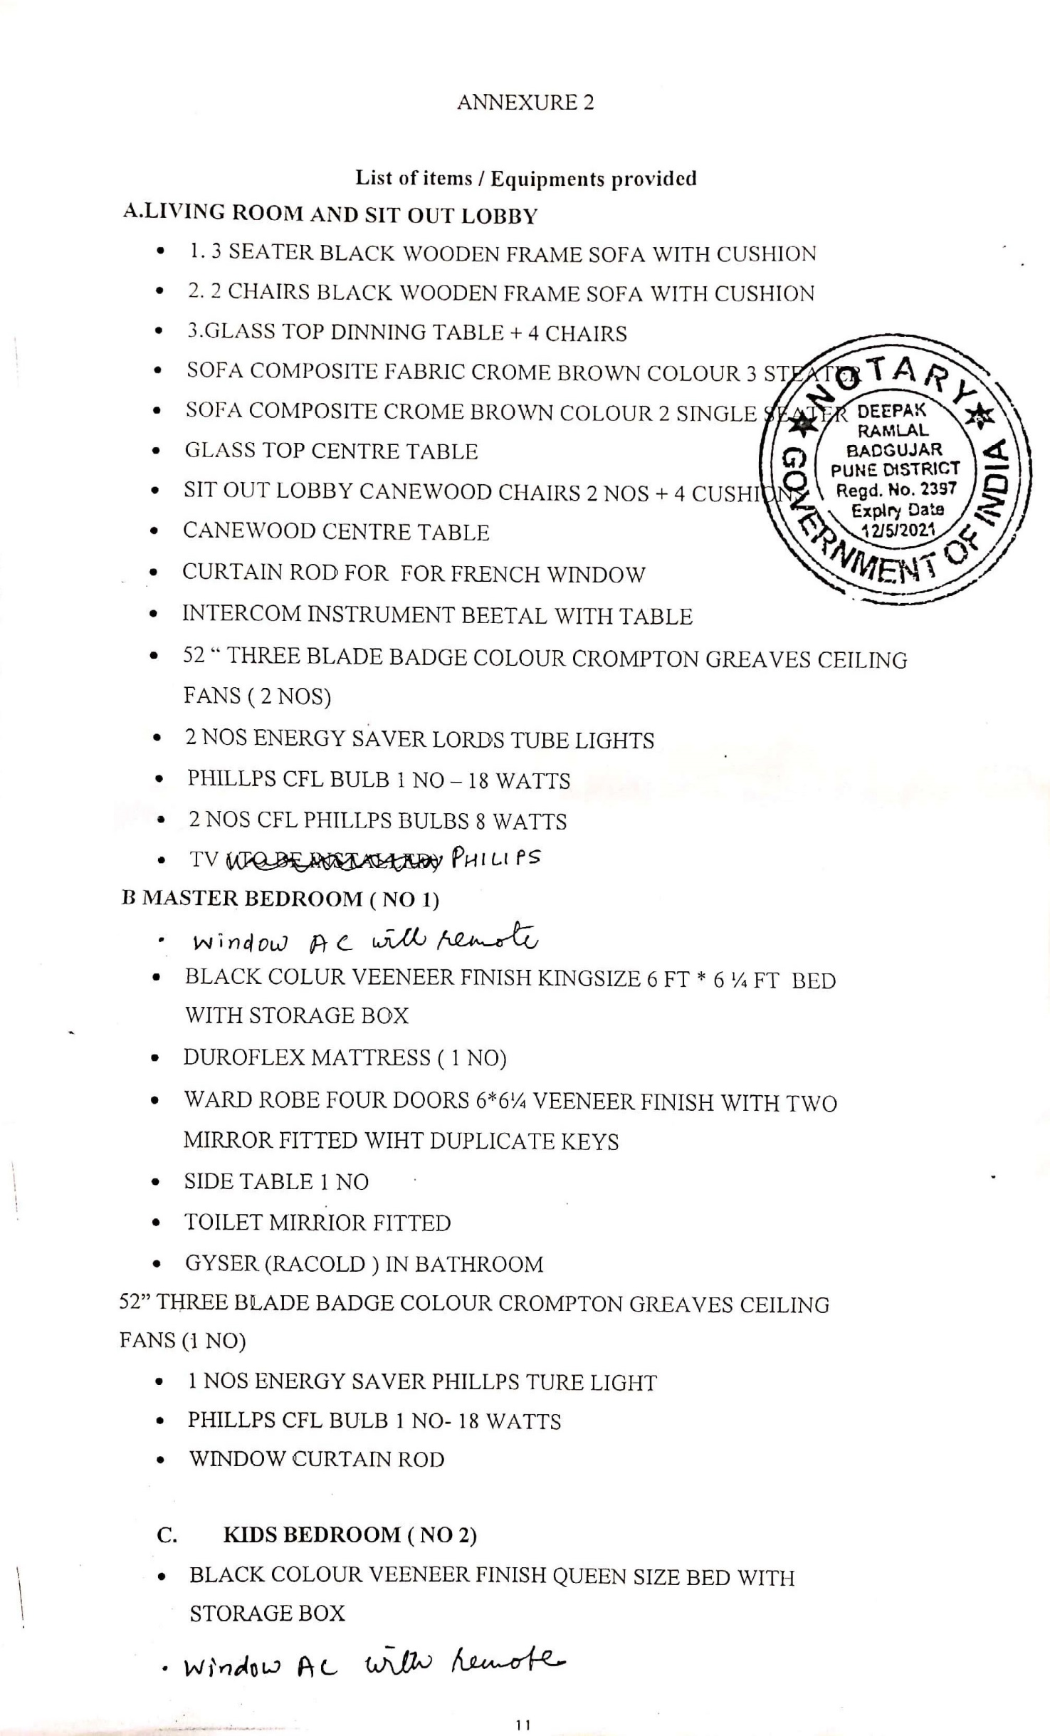

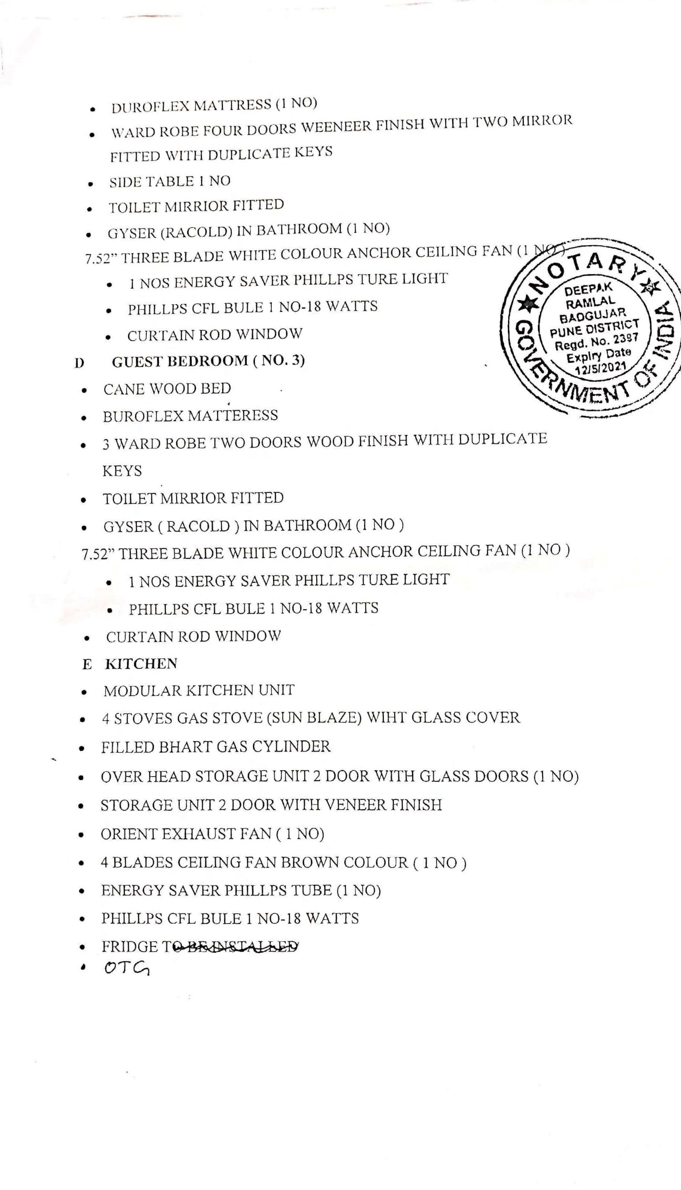

**RECEIPT**

RECEIVED FROM THE WITHINNAMED LICENCE, A SUM OF REFUNDABLE DEPOSIT ON ACCOUNT OF EXTENSION FROM 11 MONTHS TO 22 MONTHS LEASE **( RS 100,000 /-) (RUPEES ONE LAKH ONLY)** NEFT DATED **JAN 02,2020** AS AND BY WAY OF INTEREST FREE SECURITY ADDITIONAL DEPOSIT AS MENTIONED IN CLAUSE 6 OF AGREEMENT OF LEAVE AND LICENCE DATED **JAN02,2020** BETWEEN **VANDANA CHABRA** AS LICENSOR AND **PRAKASH CHOUBEY ,ROSHAN WARE, RISHI KANOJIA AND VINIT MARU** LICENCEES REFUNDABLE AT THE TIME OF TERMINATION OF THIS AGREEMENT, BEARING NO INTEREST OF LEAVE AND LICENCE OF FLAT 301, CRESCENT 2 BUILDING, THE WOODS COMPLEX WAKAD AUNDH ANNEXE PUNE 27.

**We SAY RECEIVED**

**REVENUE STAMP AND SIGNATURE**

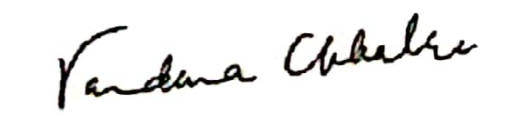

**LICENSOR**

**Date: JAN 02, 2020 (______name_____)**

**WITNESS:**

